**D.SARATH BABU-192311031**

EXP13. DEMONSTRATE INFRASTRUCTURE AS A SERVICE (IAAS) BY CREATING A VIRTUAL MACHINE USING A PUBLIC CLOUD SERVICE PROVIDER (AZURE), CONFIGURE WITH REQUIRED MEMORY AND CPU.

**AIM:**

To demonstrate infrastructure as a service (iaas) by creating a virtual machine using a public cloud service provider (azure), configure with required memory and cpu.

PROCEDURE:

**STEP1:** CREATE AN ACCOUNT IN MICROSOFT AZURE.

**STEP2:** GOTO RESOURCE GROUPAND CREATE A RESOURCE GROUP.

**STEP3:** GIVE NECESSARY THINGS FOR RESOURCE GROUP.

**STEP4:** CREATE A VIRTUAL NETWORK FOR TO CREATE A VIRTUALMACHINE .

**STEP5**: NOW CREATE A VIRTUAL MACHINE WITH UR IP ADDRESS ANUSERNAME AND PASSWORD FOR YOUR VIRTUAL MACINE.

**STEP6**: AND YOUR VIRTUAL MACHINE IS DEPLOYED.

**STEP7:** NOW CONNECT THE VIRTUAL MACHINE AND DOWNLOAD THE RDP FILETO OPEN YOUR WINDOWS VIRTUAL MACHINE.

**STEP8:** NOW RESIZE THE VIRTUAL MACHINE SIZE.

**STEP9:** CREATED A NEW WINDOWS VIRTUAL MACHINE **IMPLEMENTATION:**

**STEP1:CREATE AN ACCOUNT IN MICROSOFT AZURE.**

**STEP2: GOTO RESOURCE GROUP AND CREATE A RESOURCE GROUP.**

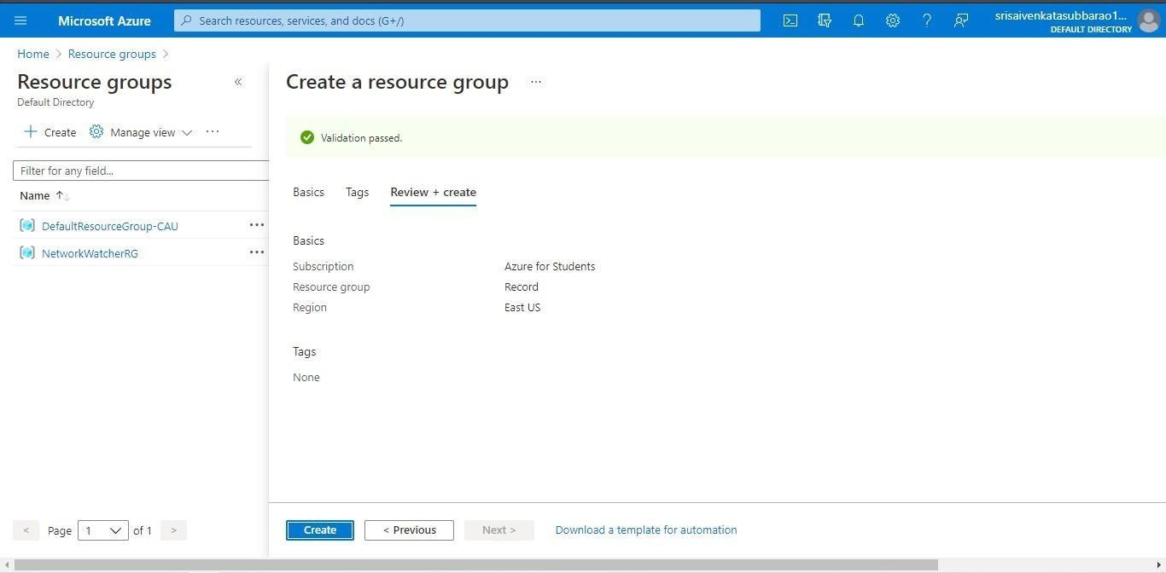

**STEP3: GIVE NECESSARY THINGS FOR RESOURCE GROUP.**

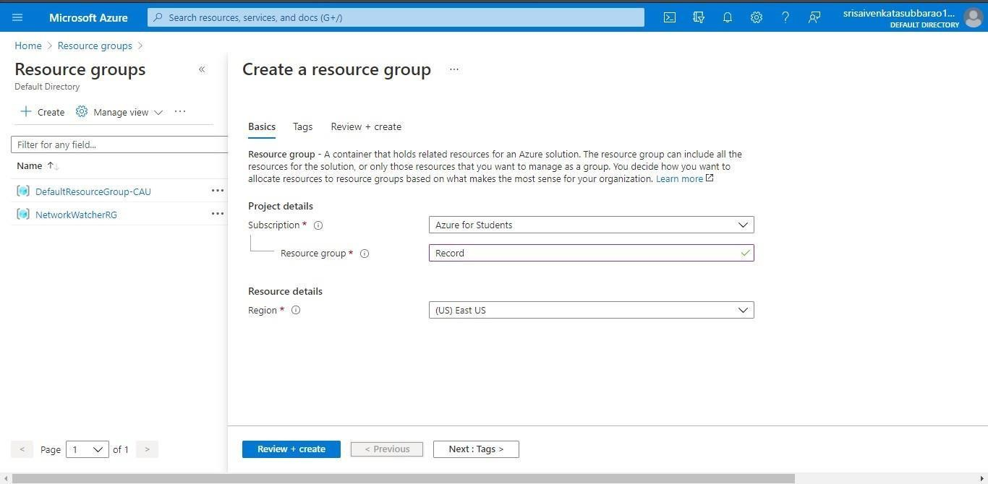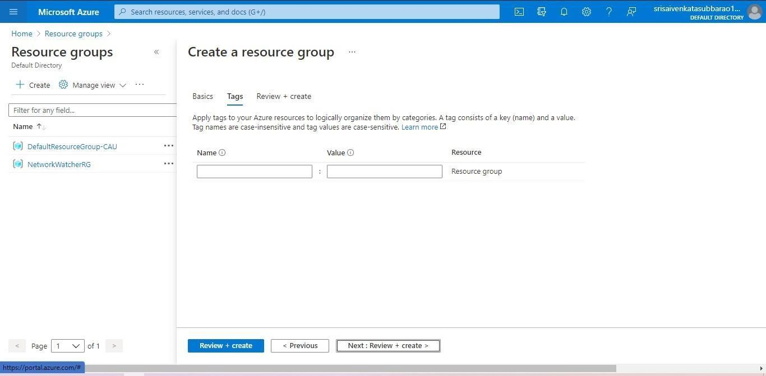

**STEP4: CREATE A VIRTUAL NETWORK FOR TO CREATE A VIRTUALMACHINE .**

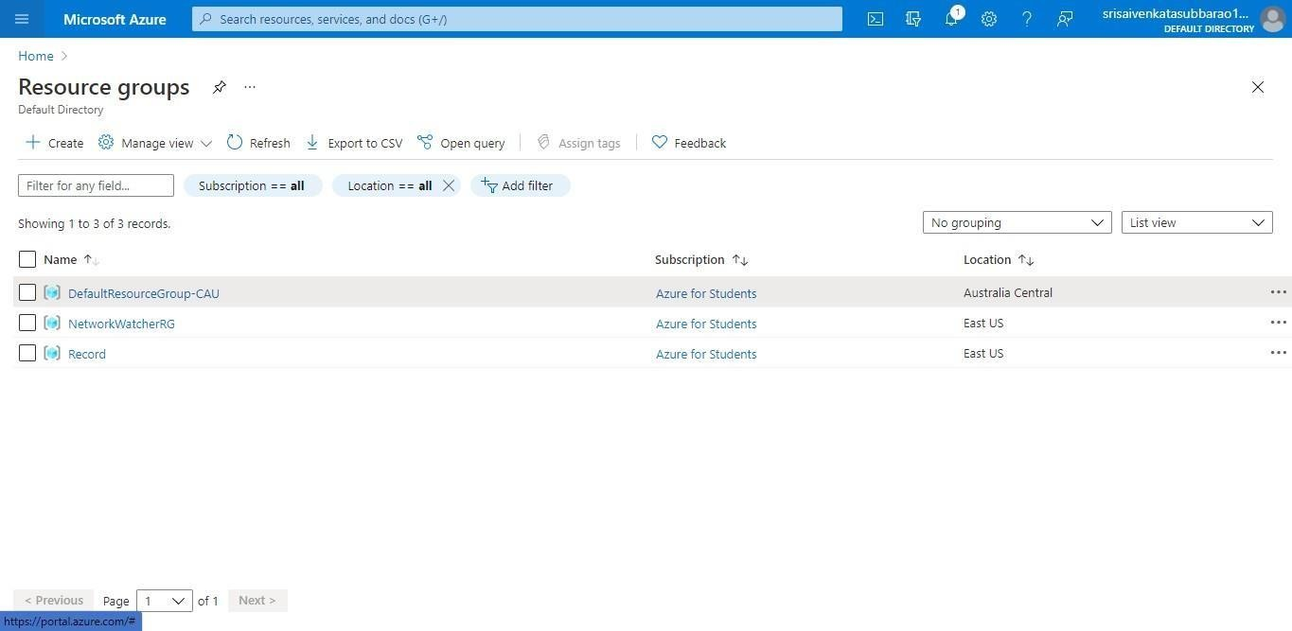

**STEP5: NOW CREATE A VIRTUAL MACHINE WITH UR IPADDRESS ANUSERNAME AND PASSWORD FOR YOUR VIRTUAL MACINE.**

**STEP6: AND YOUR VIRTUAL MACHINE IS DEPLOYED.**

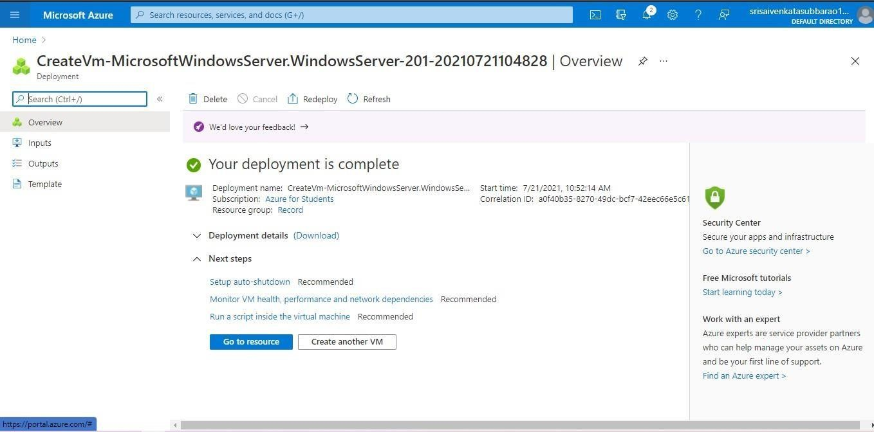

**STEP7: NOW CONNECT THE VIRTUAL MACHINE AND DOWNLOAD THE RDP FILETO OPEN YOUR WINDOWS VIRTUAL MACHINE.**

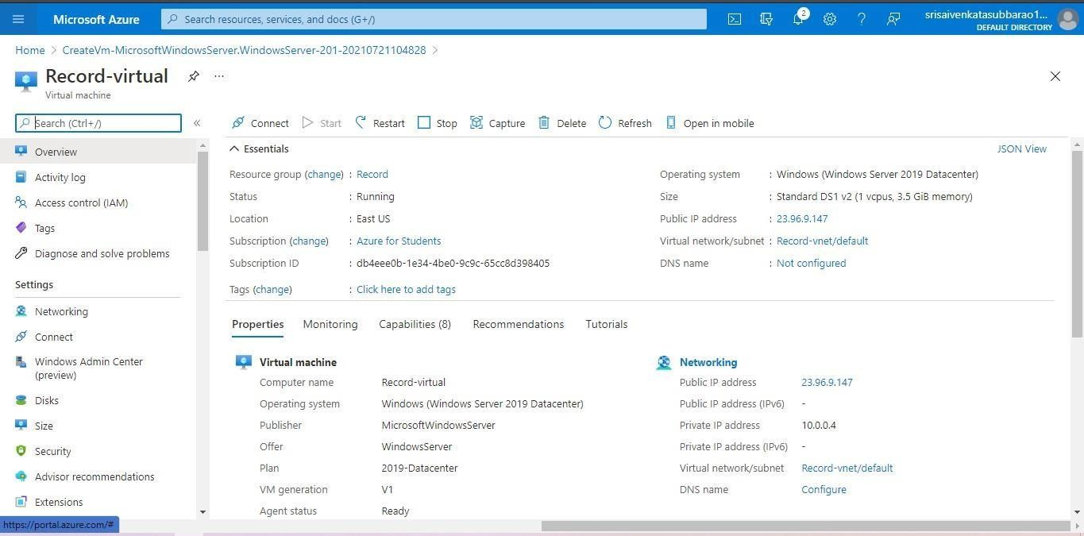

**STEP8: CREATED A NEW WINDOWS VIRTUAL MACHINE.**

